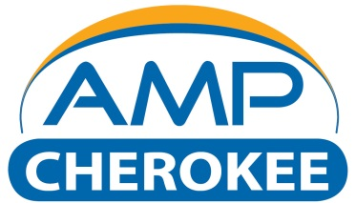

CEMS Installation Data Request Form
Client Information:
Name: |  | Date:
Company:
Address:
City: | State: |  | Zip Code:
Phone: | Mobile:
Email:

Site Information:
Company: |  | Contact:
Address:
City: | State: |  | Zip Code:
Phone: | Mobile:
Email:

Application Information:
Please describe the basic process description, pollution control devices, fuel types, load conditions:
Pollutants and parameters to be measured:
Pollutant / Parameter | Max Concentration | Min Concentration | Average Concentration | Range(s) | Unit of Measure

Background Gases:
Pollutant / Parameter | Max Concentration | Min Concentration | Average Concentration | Unit of Measure

Gas Stream Parameters:
Parameter | Max | Min | Average | Unit of Measure
H2O |  |  |  | %
CO2 |  |  |  | %
Particulate |  |  |  | Mg/M3
Particulate Size |  |  |  | Micron
Temperature |  |  |  | F
Static Pressure |  |  |  | “H2O
Flow Rate |  |  |  | SCFM

Sample Location:
Parameter | Measurement | Unit of Measure
Stack Height at Sample Point |  | Ft
Nearest Upstream/Downstream Disturbance |  | Ft
Sample Port Type
Sample Port Size
Sample Port Length |  | In
Distance to from Sample Port to Instrument Location |  | Ft
Cable Tray Installed |  | %
Available Electrical Circuits at Sample Port
Platform Width at Port |  | Ft
Platform Access

Instrument Location:
Parameter | Description
System located Indoor or Outdoor Location
If Indoor is the Location Climate Controlled
If Outdoor is There a Hazardous Location Rating
AC Power Available at System Location
Compressed Dry and Oil Free Air Supply at System Location
Compressed Air Supply Pressure
Automatic Calibration Required
Automatic Cylinder Gas Audit Desired
Preferred Communication Protocol
Calibration Gas Requirements

Plant Process Inputs:
Parameter | Range | Unit of Measure

Regulation Requirements or Reason For CEMS Installation:

Any Additional Information that will Assist AMP-Cherokee in preparing quotation:

Permanent Installation
Temporary Installation

Site Visit Requested

Required Installation Date:

Thank you for the opportunity for AMP-Cherokee to work with your upcoming CEMS needs. Please feel free to contact us with any questions regarding this form or your project.

